**Leader Overview**



**Volume Overview**

**Better Together**

*The Christian life is never lived alone. When we become a Christian, we’re adopted into God’s family. We’re welcomed into a community. We’re meant to live and grow in faith together. But that takes humility and intentionality. We grow together as we pray and study Scripture together. We bear responsibility for one another by our encouragement and our honoring of those in authority. God is growing us together as one body, one family.*

**Session Overview**

**Welcome Others**

*In this* **Live** *session, kids will discover the importance of welcoming new believers into God’s family. We must include them and help them as they leave their past behind and learn how to follow Jesus going forward. Our Bible story about Barnabas standing up for Paul shows us that no one’s past is too bad to keep us from welcoming them into the family of God.*

**Bible Lesson**

Barnabas Stands Up for Paul

[Acts 9:19–30](https://ref.ly/logosref/Bible.Ac9.19-30)

**Faith Fact**

We can help new Christians.

**Faith Verse**

[Ephesians 4:3](https://ref.ly/logosref/Bible.Eph4.3) (NLT)

Make every effort to keep yourselves united in the Spirit, binding yourselves together with peace.

**Preparing for the Session**

**Leader Preparation Time: 20–25 Minutes**

|  |
| --- |
| ***You Will Need***  ***Large Group***   * *Bible* * *Worship songs (Song suggestions: “Good Grace” by Hillsong United; “Speak Life” Lyric Video by TobyMac; “Tremble” by Bethel Music)* * *For groups not using a phone or tablet only, add:*   *• Projector or TV*  *• Laptop*  *•* ***Faith Fact Slide***  *•* ***Faith Verse Video or******Slide***  *•* ***Bible Lesson Video***  *•* ***Teaching Point Slides******1–3***   * *Toy steering wheel or cardboard cut in the shape of a steering wheel* * *Smartphone or device with a GPS app*   ***Small Group***   * *Bibles for kids in the group to share* * ***Small Group Activity Page****, one per kid* * *Pencils or pens, one per kid*   *To access session content and videos from a computer, visit:* [BibleEngagementProject.com/downloads](https://bibleengagementproject.com/downloads) |
| ***Getting Ready***  ***Large Group***   * *Download videos and slides if needed.* * *Select worship song(s) and have them ready to play.* * *Read the Bible Lesson Scripture to prepare for Teaching Time.*   ***Small Group***   * *Print copies of the* ***Small Group Activity Page****, one per kid.*   *First time leading* Live *for Kids? Check out the* [*Facilitator Guide*](https://0b769b0ed3569ef9d18b-f88d8272f61086866d50d048b43ef630.ssl.cf2.rackcdn.com/sites/biblengagementproject/Listen_Facilitator_Guide.pdf)*.* |

**Large Group**

**30 Minutes**

*See what’s needed at the beginning of the session.*

**Introduction**

Welcome back! Let’s find out more about how we are “better together.” Today, we’ll talk about welcoming others. Raise your hand if you feel welcome when you come here. *(Group response)* What’s one reason you feel welcome here? *(Allow responses.)* Those are great ways to help people feel welcome.

I want each one of you to feel welcome when you come here. I want visitors and new Christians to all feel welcome!

• *Insert a personal story about a time when you felt welcomed by other Christians at church. Try to make it specific and relatable.*

**Faith Fact**

When each of us was a new believer or new at church, we wanted to feel welcomed, right? *(Group response)* So we should look for ways to make other new believers or visitors feel the same way. To help us remember to do that, our Faith Fact today is **We can help new Christians.**

• *Show the* ***Faith Fact Slide.***

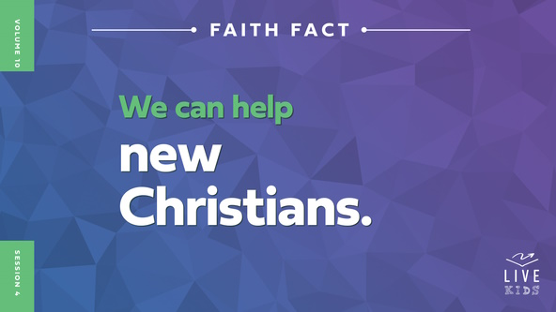

Let’s link arms with those next to us while we say the Faith Fact together. **We can help new Christians**. Let’s say it one more time. **We can help new Christians.**

**Game**

**Past, Present, Future**

Whether or not we’re a Christian, we may have done things in the past that we regret. Jesus will forgive us when we ask Him to, and we can move forward from there. We can help others leave things in the past and move forward to a better present and future with Jesus, too.

Let’s play a game called Past, Present, Future. When I say, “Past,” you will slowly walk backwards. When I say, “Present,” you will stay in the same spot and freeze. When I say, “Future,” you will move forward. Let’s see how long it takes you to make it to the other side of the room together.

• *Have all the kids line up at a starting point and show them the final spot to move toward.*

• *Play the game.*

• *Keep playing until all the kids make it to the final spot. Encourage kids who arrive first to cheer for the kids who haven’t made it yet.*

The great news is that because we have Jesus in our life, we don’t have to keep looking back at what we have done in the past. That’s our sin, and Jesus forgave that when we asked Him to. We can keep moving forward into the future God has for us. He has great things in store for us when we follow Him. He wants us to welcome and encourage others to follow Him.

**Worship**

It doesn’t matter what our background is if we’ve accepted Jesus. In Him, we are all one in the body of Christ. Let’s worship together by singing our praise to Him.

• *Lead the kids in singing one or two praise songs. See suggestions at the beginning of the session.*

**Bible Lesson**

Thanks for worshipping together with me today! Let’s pray and ask God to show us how we can make new believers feel welcome and at home.

**Prayer**

|  |
| --- |
| *Dear God, thank You for welcoming us into Your family. Help us to make others feel welcomed and loved, too. Amen.* |

**Video Intro**

Before we look at the Bible story, let’s watch this video.

• *Play* ***Bible Lesson Video****.*

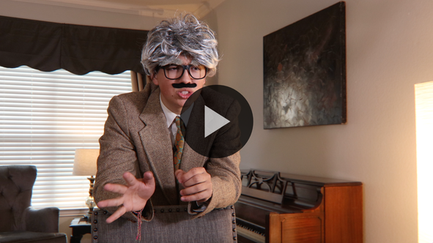

**Bible Story**

**Barnabas Stands Up for Paul**

That video was a great lead-in to our Bible story today! What is something that others might do to make someone feel unwelcome? *(Allow responses.)* Some of the Christians in today’s Bible story might have wanted to do some of those things to a new Christian named Saul. Does that surprise you? *(Group response)*

Raise your hand if you have heard about a man named Saul in the Bible. Sometimes we call him Paul. *(Group response)* Saul had a really troubled past before he became a believer. He was really mean to people who followed Jesus, but that didn’t stop God from turning Saul’s life around and welcoming Saul into His family. But the believers weren’t so sure about Saul because they had heard what he had done to people who followed Jesus.

**Teaching Time**

|  |
| --- |
| ***You Will Need***   * *Toy steering wheel or cardboard cut in the shape of a steering wheel* * *Smartphone or device with a GPS app*   *No prep needed for this activity.* |

Saul’s life was completely turned around after his unexpected encounter with Jesus. Jesus got Saul’s attention with a light that blinded him and spoke directly to him. First, a believer named Ananias helped Saul and prayed with him. God healed Saul’s eyesight before Ananias sent Saul on his way.

Our Faith Fact reminds us that it is our responsibility to help new Christians in the same ways that Ananias helped Saul. Our Faith Fact says **We can help new Christians**. Let’s find out about others who helped Saul. Grab your Bible or pull up a Bible app on your device. Turn to [Acts 9:19–30](https://ref.ly/logosref/Bible.Ac9.19-30).

• *In order to keep Large Group time moving along, we recommend that the leader reads the Scripture portions aloud.*

• *Optional: Remind the kids to mark this place with their Bible bookmark so they can read it on their own at home.*

**1. Saul immediately began to live for Jesus**.

• *Show the* ***Teaching Point 1 Slide.***

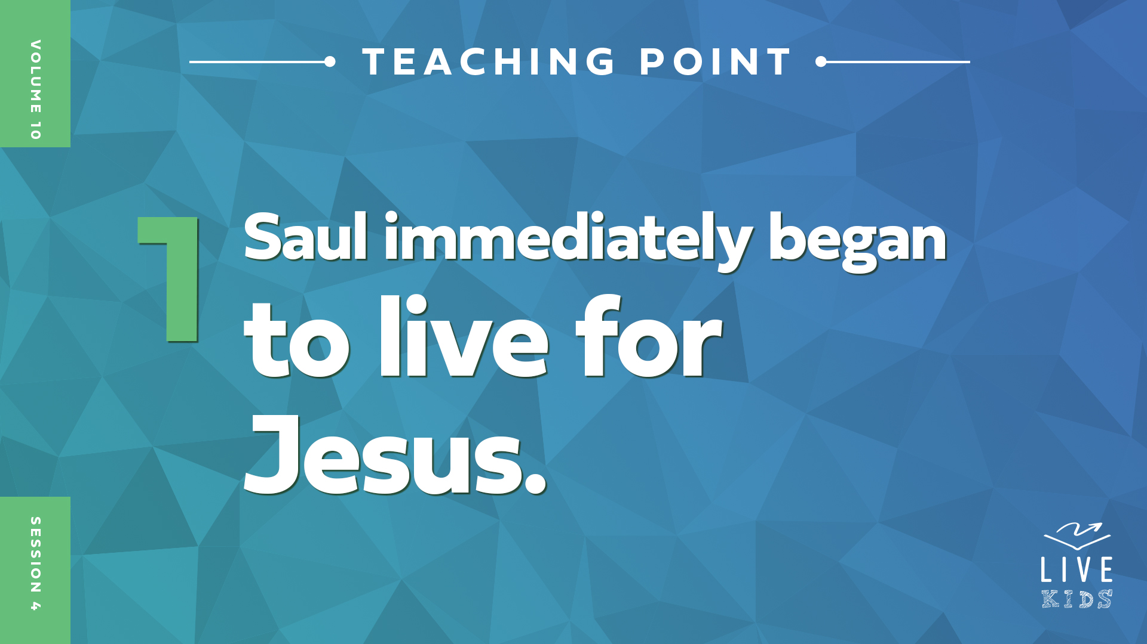

• *Read* [*Acts 9:19–22*](https://ref.ly/logosref/Bible.Ac9.19-22)*.*

Saul’s life took the craziest and most unexpected turn for the better when he chose to follow Jesus.

• *Hold up a toy steering wheel or pretend to hold a steering wheel while you talk and act it out.*

Have you ever been riding in a car when the driver made a wrong turn? *(Group response)* You might have felt completely lost until someone checked the GPS app on their device. *(Pull out your phone and turn on a GPS app.)* It tells you exactly where you need to go to get to your destination. It might even tell you to make a U-turn. By following the directions, you will eventually get where you are supposed to be going.

Jesus told Saul to make a sharp U-turn in his life. He went from hunting down Christians to becoming a Christian himself. The Bible says he immediately began preaching about Jesus. Do you think this sudden change was confusing to other people? *(Group response)* It definitely was! I can just imagine people showing up at the synagogue and doing a double-take when they saw Saul there preaching about Jesus. They may have thought, *Hold on, isn’t that the guy who was putting followers of Jesus in prison?* Understandably, not everyone knew how to handle Saul’s change in direction and his decision to follow Jesus.

**2. Some believers didn’t welcome Saul, but others did.**

• *Show the* ***Teaching Point 2 Slide.***

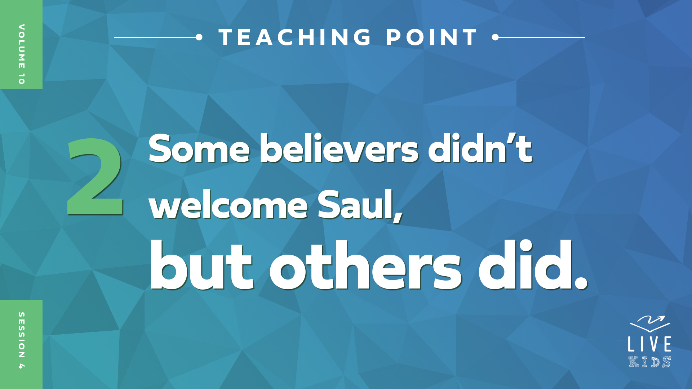

• *Read* [*Acts 9:23–26*](https://ref.ly/logosref/Bible.Ac9.23-26)*.*

Did all the Christians treat Saul like he was part of God’s family? *(Group response)* Definitely not! Some of the believers welcomed him, and some were afraid of him. At the same time, there were other people who weren’t Christians who plotted to kill him. Saul went from hating Christians and trying to hurt them to being a Christian that others wanted to hurt.

What was the right response from Christians to Saul’s change of heart? *(Allow responses.)* The right thing to do was to welcome him. But can you blame the people who were scared of him? *(Group response)* Do you think you would have helped him? *(Group response)*

How we welcome new believers can make a big impact. All the believers who welcomed Saul, kept him safe, and helped him made it possible for Saul to learn more about his new faith and focus on what God wanted him to do. Because of that, Saul led many people to faith in Jesus, helped to start churches, performed miracles, and wrote almost half of the books in the New Testament.

**3. Barnabas stood up for Saul and became his friend.**

* *Show the* ***Teaching Point 3 Slide.***

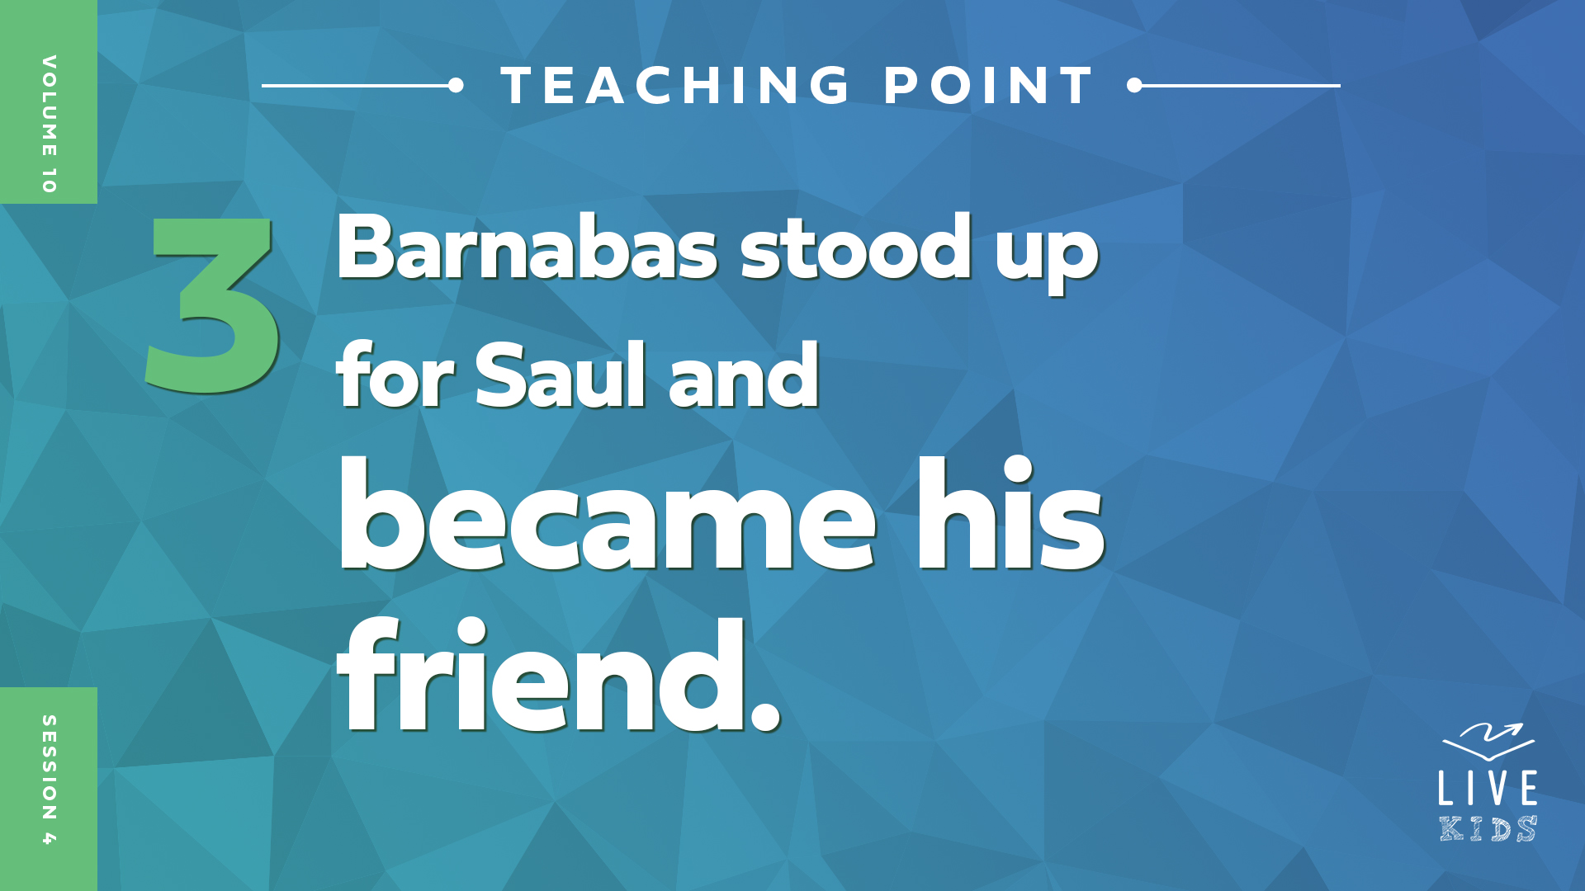

• *Read* [*Acts 9:27–30*](https://ref.ly/logosref/Bible.Ac9.27-30)*.*

Not everyone agreed about Saul. Some people were afraid to let Saul be a part of the church, but some people were okay with it. Remember how we learned that we could go to leaders to solve disagreements? *(Group response)* So that’s what Barnabas did. He took Saul to the church leaders.

Barnabas stood up for Saul. He shared about Saul’s encounter with Jesus and how Saul had been boldly preaching in Jesus’ name ever since. These church leaders welcomed Saul, and he preached boldly.

It probably took a lot of forgiveness and grace from believers to welcome Saul after all he had done in the past. Barnabas and the believers who took care of Saul knew that God had called them to welcome new Christians, even those with ugly pasts. They showed us that the church should be a place where everyone is welcome.

**Prayer and Response**

*Consider playing a worship song softly in the background while kids pray.*

Maybe you relate to Saul because you are a newer believer. Maybe you relate to Barnabas because you like to welcome others. We must choose to welcome each other into God’s family despite our past and our differences. We can help each other learn more about Jesus and grow in our faith in Him.

Raise your hand if you are a new believer or if you are new to our group. *(Group response.)* If you don’t have your hand raised and have been a Christian for a while, look for someone who is raising their hand. Go to them, introduce yourself, and welcome them to our church family.

• *Give kids time to respond.*

**Prayer**

*Optional: Have the kids repeat phrases of the prayer after you.*

|  |
| --- |
| *Dear God, thank You for inviting everyone to be a part of Your family. Help me to be willing to welcome everyone and stand up for them when they need my help. Amen.* |

**Faith Verse**

Our Faith Verse talks about being united with other believers. That includes welcoming others into our church family. Let’s say our Faith Verse and do the actions together.

• *Play* ***Faith Verse Video****.*

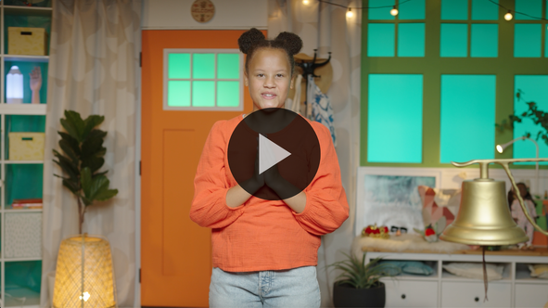

[Ephesians 4:3](https://ref.ly/logosref/Bible.Eph4.3) (NLT)

Make every effort to keep yourselves united in the Spirit, binding yourselves together with peace.

**Faith Fact**

Before we go to our small groups, let’s review our Faith Fact again. **We can help new Christians.**

• *Show the* ***Faith Fact Slide****.*



Let’s say our Faith Fact together one more time as slowly as possible. **We can help new Christians.** Remember to look for ways to help others and make them feel welcome this week.

• *Dismiss kids to Small Group time or to go home if your group time ends here.*

**Small Group**

**30 Minutes**

*This section can be done in conjunction with the large group or on its own if you do small groups with your kids. During Small Group time, the goal is to connect the kids with the Word of God and to each other. All activities are led by the small group leader.*

**Group Connection**

**Stand Up If …**

|  |
| --- |
| *No prep is needed for this activity.* |

One way we can make new believers feel welcome is by standing up for them like Barnabas stood up for Saul. When we are willing to stand up for each other and have each other’s back, we are better together. Let’s play a game about that. If what I say applies to you, stand up and keep standing. I’ll keep saying things until everyone in the group is standing together.

• *Say statements about things like these until everyone is standing: Favorite color is orange, ate breakfast today, have a pet, wearing socks, favorite snack is a cookie, etc.*

We don’t all have the same likes and dislikes, but we can stand up for each other, especially when someone is a new Christian or new to our group. Like our Faith Fact says, **We can help new Christians.**

• *Optional: Play again, allowing the kids to name things to stand up for.*

**Bible Lesson Recap**

• *If small group activities are not immediately following large group time, you may want to read the Bible story passage before the discussion.*

|  |
| --- |
| ***You Will Need***   * *Bibles for kids in the group to share*   *No prep needed for this activity.* |

**Bible Story Review: Barnabas Stands Up for Paul** [**Acts 9:19–30**](https://ref.ly/logosref/Bible.Ac9.19-30)

Saul went from wanting to throw believers in prison to preaching about Jesus everywhere he went after he met Jesus. That moment was life-changing for Saul, but the other believers weren’t sure what to think about this major change in his life. Could they trust Saul? Did they even want him to be a part of the church? Had he really changed? These are all questions I’m sure the believers were asking themselves about Saul.

Barnabas was one of the believers who chose to welcome Saul and stood up for him. He had seen the change in Saul and knew that God had completely changed his life. Barnabas wanted to convince others to believe the same about Saul.

• *Give each kid a Bible and read the Bible story together.*

**Group Discussion**

*Feel free to use all or just a few questions as a jumping-off place for good discussion. Questions marked with * are designed for more conversation. Adjust the questions based on the age or maturity of your group. Typically, older kids will be able to dive a little deeper than younger ones.*

**Questions**

Why did Saul need to have an encounter, or meet, with Jesus?

What did Saul do immediately after he became a believer?

Who stood up for Saul to the other believers?

How did Saul’s life change after he started following Jesus?

Why were people surprised to see Saul preaching about Jesus?

Why was Saul’s life in danger?

How did Barnabas welcome Saul as a new believer?

* Do you think it would have been hard to welcome Saul as a believer? Why or why not?

Do you know anyone who is a new believer?

* How can you welcome new believers?

**Live It**

**Faith Fact**

Our Faith Fact today is **We can help new Christians**. The believers had a choice to make when they saw Saul had become a believer. They could choose to welcome him and forgive him for his past, or they could ignore him and send him away. Barnabas and some of the other believers welcomed Saul and helped keep him safe. God is calling all of us to welcome new Christians into the family of God. We can help them overcome their past and look forward to a bright future of following Jesus.

**Challenge**

If you know someone who is a new Christian, look for ways to help them this week. If you don’t know any new Christians, it’s time to add some new believers to the family. Look for opportunities to share your faith with people who don’t know Jesus.

**Prayer**

*Finish group discussion by sharing prayer requests and praise reports. Keep track of your small group’s prayer requests and review them each time you meet.*

• *Have kids share and pray for each other’s prayer requests.*

|  |
| --- |
| *Dear God, help us find ways to welcome and help new believers. We want to be welcoming like Barnabas and stand up for other believers. Amen.* |

**Faith Verse Review**

Our Faith Verse is [Ephesians 4:3](https://ref.ly/logosref/Bible.Eph4.3). It reminds us to be united with each other. That includes welcoming any new believers to be a part of the Church.

• *Show* ***Faith Verse Video****.*



[Ephesians 4:3](https://ref.ly/logosref/Bible.Eph4.3) (NLT)

Make every effort to keep yourselves united in the Spirit, binding yourselves together with peace.

Let’s say it together again before we do a fun Faith Verse activity together.

• *Say the verse as a group.*

**Faith Verse Fun**

**Stand Up Verse**

Hopefully you have memorized our Faith Verse and are ready to play this speedy game. It will take the whole group working together to say the Faith Verse. One at a time, you will stand up and say one word of the Faith Verse and then quickly sit back down. We will keep going around the circle until we have said the entire Faith Verse. If anyone gets stuck on a word, the group will help you out. Are you ready to play? *(Group response)* Let’s go.

• *Say the verse with one person saying one word at a time.*

That was pretty impressive how you worked together to say the Faith Verse so fast. Well done!

**Activity Page**

**Find a Friend**

|  |
| --- |
| ***You******Will Need***   * ***Small Group Activity Page****, one per kid* * *Pencils or pens, one per kid*   ***Getting Ready***   * *Print copies of the* ***Small Group Activity Page****, one per kid.* |

We’ve talked about welcoming new people into God’s family, so I thought we should do something different with our Activity Page. God wants us to help people. That means we need to get to know people and become friends with them.

• *Hand out a copy of the* ***Small Group Activity Page*** *and a pencil to each kid.*

To complete the page, you need to find someone who can sign each box. When you’re done, count how many different people signed your page and write that number in the last box. I hope you find eight different people to sign and get to know something about them.

• *Have the kids complete the page.*

• *Optional: Talk about what they learned about others in the group.*

**Dismissal**

Thanks for being a part of our group and the family of God. Remember, you are always welcome here! Let’s make everyone else who comes feel welcome too. Let’s pray together one more time before we go.

**Prayer**

|  |
| --- |
| *Dear God, thank You for welcoming us with open arms into Your family. Help us to welcome everyone with the same love and grace that You show to us. Amen.* |

**Faith Fact Recap**

• *Show the* ***Faith Fact Slide****.*



Remember today’s Faith Fact. **We can help new Christians.** Turn around in a circle and look at everyone as you do so. *(Group response)* Let’s end today with the reminder that we are better together! Don’t just say it. Make sure you live it out every day.

• *Send home the* ***Small Group******Activity Page.***

• *Remind parents that there are* ***Family Devotions*** *available on the app to do with their kid.*

• *Tell everyone the date and time for the next session.*

.